T1.

<!DOCTYPE html>

<html lang="en">

<head>

<meta charset="UTF-8">

<meta name="viewport" content="width=device-width, initial-scale=1.0">

<title>Change Styles on Button Click</title>

<style>

body {

text-align: center;

padding: 50px;

}

</style>

<script>

function changeStyles() {

var heading = document.getElementById('mainHeading'

document.body.style.backgroundColor = 'lightpink';

heading.innerHTML = 'Hello Everyone!';

}

</script>

</head>

<body>

<h1 id="mainHeading">Welcome to my Webpage</h1>

<button onclick="changeStyles()">Change Styles</button>

</body>

</html>

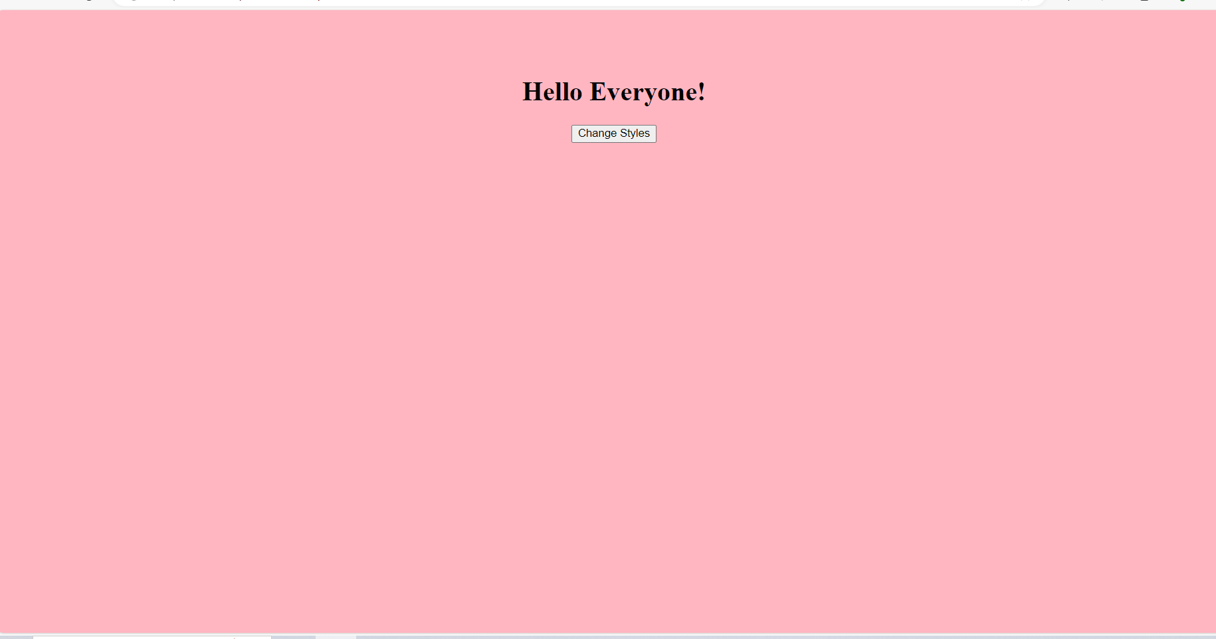

T2.

<!DOCTYPE html>

<html lang="en">

<head>

<meta charset="UTF-8">

<meta name="viewport" content="width=device-width, initial-scale=1.0">

<title>Changing Styles</title>

<style>

body {

text-align: center;

padding: 50px;

}

</style>

<script>

function changeStyles() {

var heading = document.getElementById('mainHeading');

document.body.style.backgroundColor = 'lightgreen';

heading.style.color = 'red';

heading.style.fontSize = '48pt';

heading.innerHTML = 'Hello Everyone!';

document.body.innerHTML += '<button>Click Me</button>';

}

</script>

</head>

<body>

<h1 id="mainHeading">Welcome to my Webpage</h1>

<button onclick="changeStyles()">Change the Style of this webpage</button>

</body>

</html>

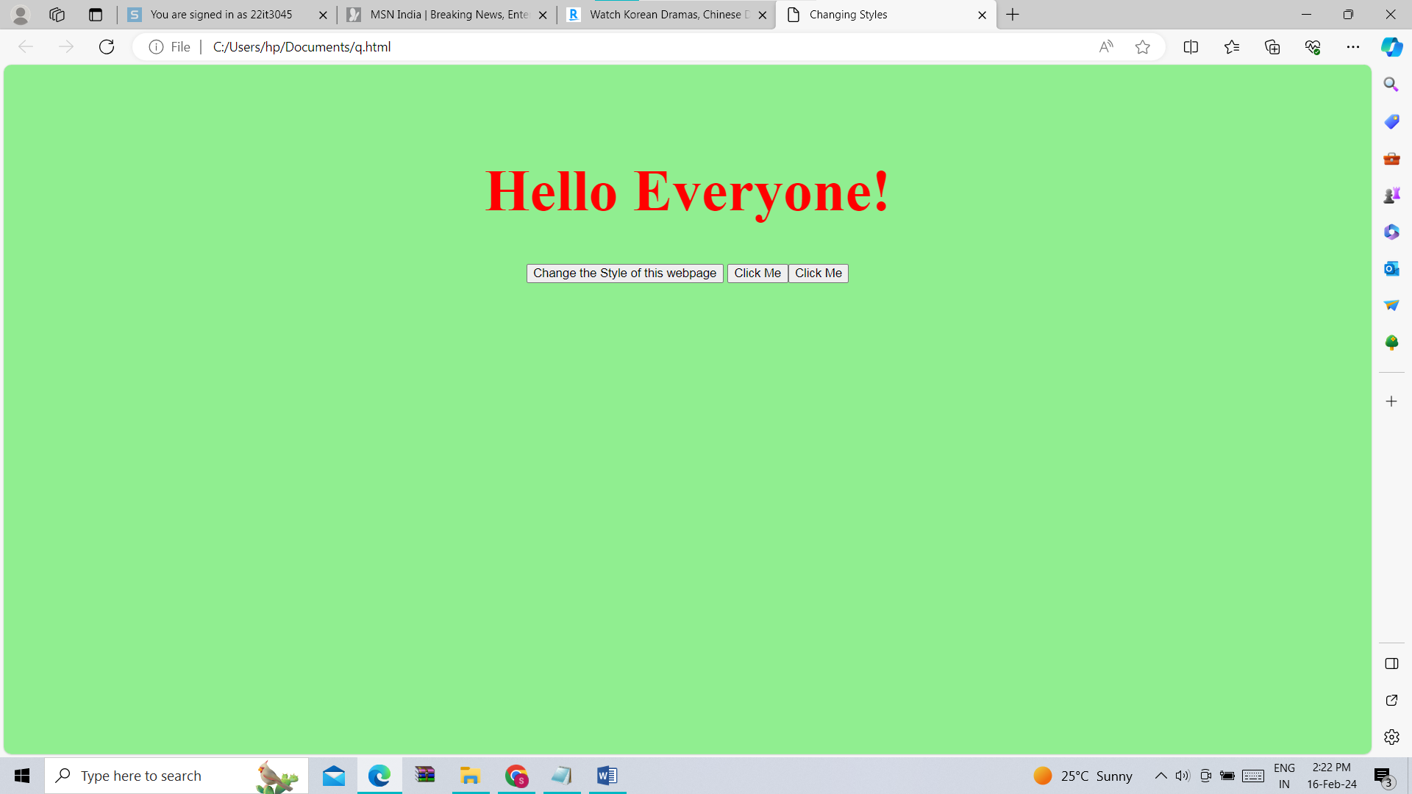

T3.

<!DOCTYPE html>

<html lang="en">

<head>

<meta charset="UTF-8">

<meta name="viewport" content="width=device-width, initial-scale=1.0">

<title>TASK 3</title>

<style>

.custom-background {

background-color: lightpink;

}

body {

text-align: center;

padding: 50px;

}

</style>

<script>

function applyCustomBackground() {

alert('Before assigning class attribute');

document.body.className = 'custom-background';

alert('After assigning class attribute');

}

</script>

</head>

<body>

<h1>Welcome to my Webpage</h1>

<button onclick="applyCustomBackground()">Apply Background</button>

</body>

</html>

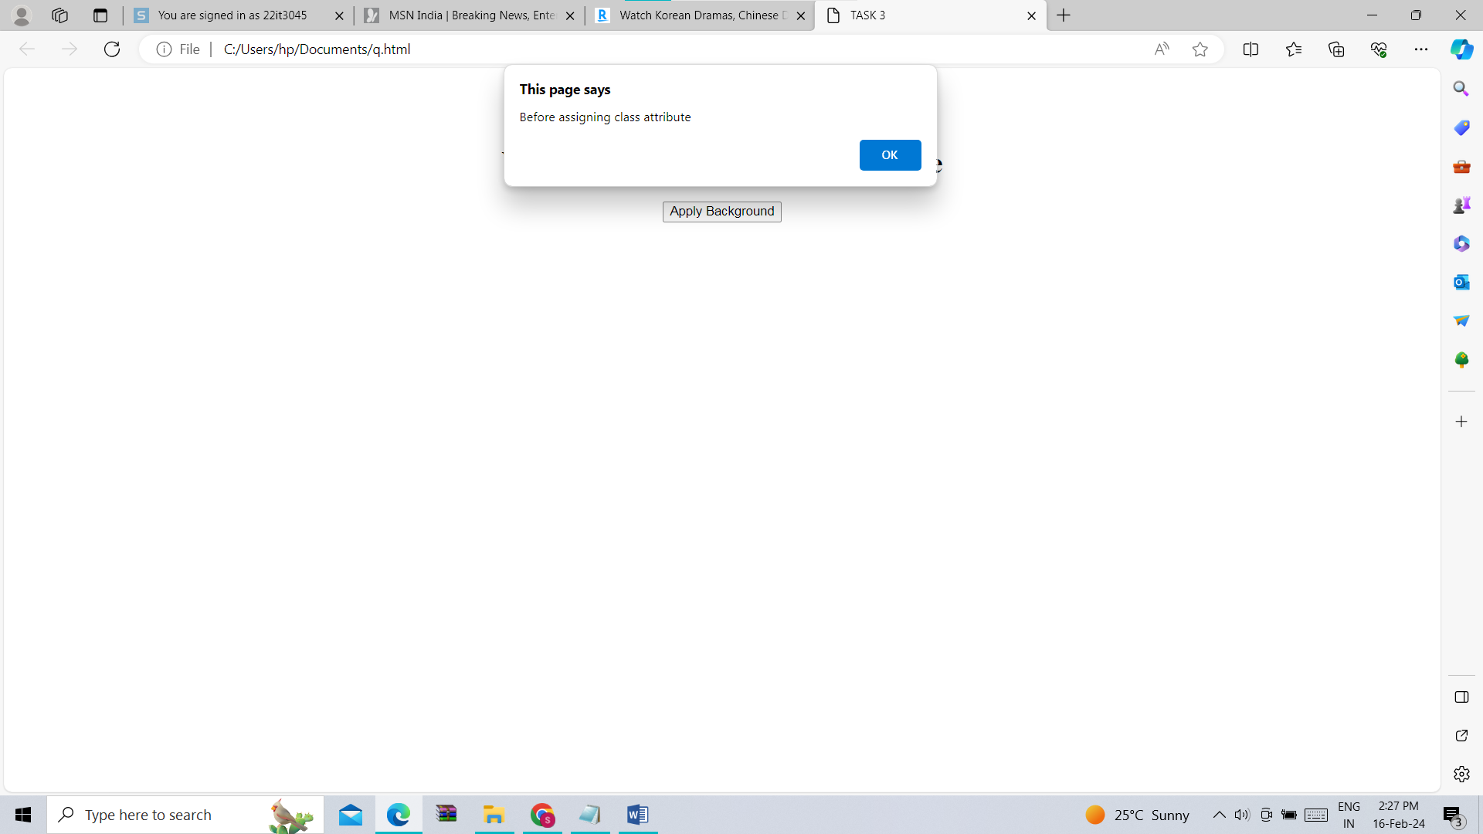

T4.

<!DOCTYPE html>

<html lang="en">

<head>

<meta charset="UTF-8">

<meta name="viewport" content="width=device-width, initial-scale=1.0">

<title>TASK 4</title>

<style>

body {

font-family: Arial, sans-serif;

margin: 0;

padding: 0;

}

header {

background-color: #333;

color: white;

padding: 10px;

text-align: center;

}

main {

padding: 20px;

}

#content1, #content2 {

display: none;

}

button {

padding: 10px;

background-color: #4CAF50;

color: white;

border: none;

cursor: pointer;

}

</style>

</head>

<body>

<header>

<h1>Welcome to my Web Page</h1>

</header>

<main id="main-section">

<div id="content1">

<h2>Page 1</h2>

<p>Hello, I am currently enrolled in RGIPT as a 2nd year student.</p>

</div>

<div id="content2">

<h2>Page 2</h2>

<p>Hello, I am currently studying Information Technololy.</p>

</div>

<button onclick="changeContent()">Change the Content</button>

</main>

<footer>

<p>The footer content is available outside the main section.</p>

</footer>

<script>

function changeContent() {

var content1 = document.getElementById("content1");

var content2 = document.getElementById("content2");

content1.style.display = (content1.style.display === 'none') ? 'block' : 'none';

content2.style.display = (content2.style.display === 'none') ? 'block' : 'none';

}

</script>

</body>

</html>

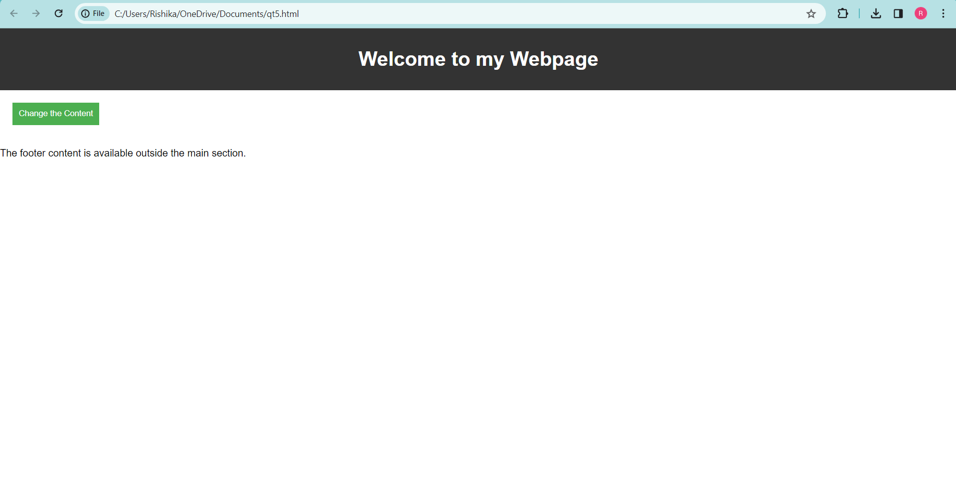

T6.

<!DOCTYPE html>

<html lang="en">

<head>

<meta charset="UTF-8">

<meta name="viewport" content="width=device-width, initial-scale=1.0">

<title>Web Browsers with their latest Versions</title>

<style>

body {

font-family: Arial, sans-serif;

margin: 0;

padding: 0;

}

.container {

display: grid;

grid-template-columns: repeat(auto-fit, minmax(100px, 1fr));

gap: 10px;

padding: 20px;

}

.browser {

display: flex;

flex-direction: column;

align-items: center;

}

.icon {

width: 50px;

height: 50px;

margin-bottom: 5px;

}

</style>

</head>

<body>

<div class="container">

<div class="browser">

<img src="C:\Users\hp\Downloads\chrome.jpg" alt="Chrome" class="icon">

<span>Latest Version: 57.0</span>

</div>

<div class="browser">

<img src="C:\Users\hp\Downloads\firefox.jpg" alt="Firefox" class="icon">

<span>Latest Version: 200</span>

</div>

<div class="browser">

<img src="C:\Users\hp\Downloads\edge.jpg" alt="Edge" class="icon">

<span>Latest Version: 16.0</span>

</div>

<div class="browser">

<img src="C:\Users\hp\Downloads\safari.jpg" alt="Safari" class="icon">

<span>Latest Version: 400</span>

</div>

<div class="browser">

<img src="C:\Users\hp\Downloads\opera.jpg" alt="Opera" class="icon">

<span>Latest Version: 400</span>

</div>

</div>

</body>

</html>

